KINDLY SPONSORED BY ‘THE NORTHERN SNOOKER CENTRE’

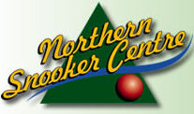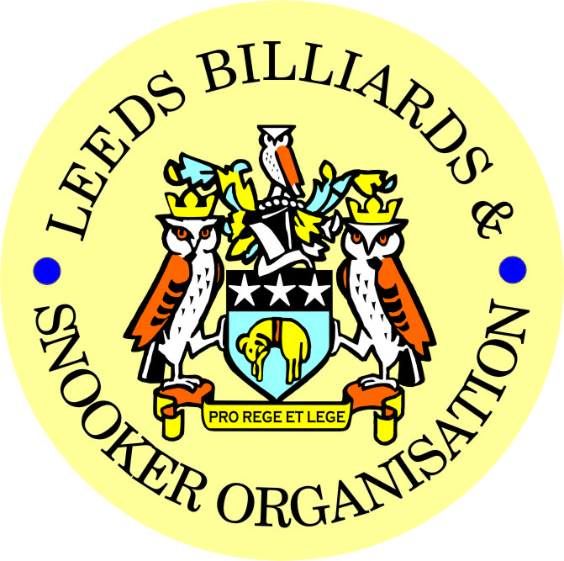

**2015-2016 PRIZE PRESENTATION EVENING**
**WEDNESDAY 13th JULY 2016**
** BRAMLEY BAND CLUB**

** LEEDS CITY CHAMPIONSHIPS - JUNIORS **
U.16’s & U.18’s – SNOOKER – (Scratch)

UNDER 16’s SNOOKER:
New Trophy – Presented by ADT Flexibles (UK) Ltd.
WINNER: LEWIS HARPER | RUNNER-UP: KAIF SHAZAD
SEMI-FINAL: SAMUEL LEE-STEVENS | SEMI-FINAL: CASEY RATCLIFFE
UNDER 18’s SNOOKER:
“The Keith Weston Memorial Trophy”- Presented by ADT Flexibles (UK) Ltd.
WINNER: LEWIS HARPER | RUNNER-UP: KIERON SAVAGE
SEMI-FINAL: OLIVER MULCAHY | SEMI-FINAL: KAIF SHAZAD
JUNIOR HIGH BREAK: - “The Paul Hunter Memorial Trophy” – LEWIS HARPER

**2015-16 YBSA – YORKSHIRE INTER-DISTRICT LEAGUES**

SNOOKER LEAGUE  DIVISION 1  LEEDS No.1  Squad Players | SNOOKER LEAGUE  DIVISION 2  LEEDS No.2  Squad Players
Anthony Massey (Captain) | Stephen Broadhead (Captain)
Mark Ball | Chris Hart
Jason Braithwaite | Tommy Doherty
Mick Jensen | Michael Savery
Ian O’Brien | Dave Barker

SNOOKER - “Veterans Trophy” | REFEREES:  Officiated in 2015-16 LBSO Competitions:
WINNER: CHARLIE McGUIGAN | ALEX CRUM
RUNNER-UP: ALAN SOWDEN | KENNETH SYMONS
 | PETER WALKER
PLATE WINNER: BRIAN PRITCHARD | MICHAEL DAVENPORT
PLATE RUNNER-UP: PAUL GRIMES | SIMON COYNE
 | MARK KING
 | BOB PATTERSON

PRESENTATION OF SPECIAL AWARD – To be announced on the night

Break for Entertainment – Main Presentation to follow afterwards:

** LEEDS CITY CHAMPIONSHIPS **
(Scratch)
INDIVIDUAL SNOOKER:
WINNER: JOHNATHAN BAGLEY | RUNNER-UP: ANTHONY MASSEY
SEMI-FINAL: RICHARD BINNS | SEMI-FINAL: STEPHEN BROADHEAD
PAIRS SNOOKER:
New Trophy – Presented by ADT Flexibles (UK) Ltd.
WINNERS: J.BAGLEY / C. HART | RUNNERS-UP: L.GILLEN / J.GILLEN
SEMI-FINAL: A. SUMNER / D. SELLY | SEMI-FINAL: D.KNIGHT / S. STEVENS
TEAM SNOOKER – “The Jim Fowler’s Trophy”:
WINNERS: NORTHERN SNOOKER CENTRE | RUNNERS-UP: NEW WORTLEY LABOUR

LEN LEE INVITATION SNOOKER – (Scratch):  “THE LEN LEE TROPHY” | WINNER: ANTHONY MASSEY  RUNNER-UP: JOHNATHAN BAGLEY

** LBSO - BILLIARDS & SNOOKER LEAGUES **

Div: | CUP TITLE / WINNERS: | RUNNERS-UP:
Billiards | The Yorkshire Evening News Cup:  SOUTH LEEDS CONS | SWARCLIFFE WMC
Div A | The Yorkshire Evening News Shield:  MAIN LINE SOCIAL ‘A’ | BRAMLEY WMC ‘A’
Div B | The Clan Tartan Trophy:  BRAMLEY BAND ‘B’  (YORKSHIRE RIDER) | CROSSGATES REC HALL ‘A’
Div C | The John Dunning Trophy:  BELLE ISLE WMC ‘B’ | MAIN LINE SOCIAL ‘B’
Div D | The J. H. Lunn Cup:  CROSSGATES WMC ‘A’ | ADRIAN SOCIAL
Div E | The Peter Nelson Trophy:  NORTHERN SNOOKER CENTRE ‘B’ | EDMUND HOUSE ‘B’
Div F | The Peter Hawkyard Memorial Trophy:  CROSSGATES REC HALL ‘B’ | BRAMLEY VILLAGERS ‘B’
Div G | The J. McDonnell / J. Williamson Trophy:  HORSFORTH CONS | MORLEY CONS ‘B’
Div H | The Keith Darley Trophy:  BELLE ISLE WMC ‘D’ | BRAMLEY VILLAGERS ‘C’

“CHAMPION of CHAMPIONS”  “The Jim Williamson Memorial Trophy”  Presented by the Northern Snooker Centre | WINNERS: MAIN LINE SOCIAL ‘A’  (DIVISION A WINNERS)
SNOOKER – Individual Handicap.
The “GEORGE SYKES CUP”
WINNER: KARL PAYNE  (BEECHWOOD WMC) | RUNNER-UP: RICHARD NELSON  (EAST LEEDS S. C.)
SEMI-FINAL: SEAN STEVENS  (NEW WORTLEY LABOUR) | SEMI FINAL: JOSH BECIC  (NEW WORTLEY LABOUR)

SNOOKER – Pairs Handicap.
The “LEN LEE CUP”
WINNERS: J. BAGLEY & A. BUTTERWORTH  (HAREHILLS LABOUR) | RUNNERS-UP: T. BURDEN & P. WALKER  (CROSSGATES REC. HALL)
SEMI-FINAL: P. BUCKLE & S. QUIGLEY  (NEW MIDDLETON CLUB) | SEMI-FINAL: I. O’BRIEN & S. O’BRIEN  (HARHILLS WMC)

SNOOKER - 3 MAN TEAM KNOCK OUT – (Handicap).
The “Leeds & District Billiards League Snooker Cup”
WINNERS: HAREHILLS LABOUR ‘A’ | RUNNERS-UP: HUNSLET CARR S + S ‘A’
SEMI-FINAL: PEGGY TUB SOCIAL ‘A’ | SEMI FINAL: SEACROFT WMC ‘A’

BILLIARDS HANDICAP:  “YORKSHIRE EVENING POST SHIELD” | WINNER: FRED SMITH (Morley Cons)  RUNNER-UP: M. McGUIGAN (Bramley Band)

** STAN BROOKE MEMORIAL COMPETITIONS **
(AGGREGATE SCORES)
INDIVIDUAL SNOOKER – 3 FRAMES:
WINNER: PHIL BUCKLE  (NEW MIDDLETON CLUB) | RUNNER-UP: DARREN BINNS  (HUNSLET CARR S + S)
SEMI-FINAL: ANDY TAFFINDER  (ACKROYD STREET WMC) | SEMI FINAL: MICHAEL GAUGHAN  (ROWLAND ROAD WMC)
PAIRS SNOOKER – 3 FRAMES:
WINNERS:  I.RAYNER & L. NAYLOR-HAIGH  (PEGGY TUB SOCIAL) | RUNNER-UP:  - MASSEY & S. O’BRIEN  (HAREHILLS WMC)
SEMI-FINAL  R. HOLT & G. TAYLOR  (DENISON HALL CLUB) | SEMI-FINAL:  J. WILKINSON & B. GREEN  (SEACROFT WMC)
TEAM SNOOKER – 4 FRAMES:
WINNERS: ACKROYD STREET WMC‘A’ | RUNNERS-UP: BELLE ISLE WMC ‘D’
SEMI-FINAL: HAREHILLS LABOUR ‘A’ | SEMI-FINAL: EAST END PARK WMC ‘A’

The “WINDSOR TROPHY” – 4 Man Team Handicap
New Trophy – Presented by ADT Flexibles (UK) Ltd.
WINNERS: SOUTH LEEDS CONS | RUNNERS-UP: HORSFORTH CONS
SEMI-FINAL: BRAMLEY VILLAGERS | SEMI FINAL: ADEL MEMORIAL

LBSO LEAGUE - HIGHEST BREAKS – BILLIARDS & SNOOKER
Billiards ‘A’ – (-200 to +19) | 79 – Paul Aldcroft – Rowland Road WMC
Billiards ‘B’ – (+20 to +200) | 48 – Paul Easton Swarcliffe WMC
Snooker – Group 1 (-80 to -20) | 118 – Michael Tomlinson (-25) – Northern Snooker Centre ‘A’
Snooker – Group 2 (-19 to +5) | 101 – Stuart Jauncey (-15) – Northern Snooker Centre ‘D’
Snooker – Group 3 (+6 to +20) | 70 – Gareth Priestley (+15) – Main Line Social ‘B’
Snooker – Group 4 (+21 to +30) | 63 – Ben Matthews (+28) – Drighlington T.C. Club ‘B’
Snooker – Group 5 (+31 to +80) | 45 – Paul Whittaker (+33) – Belle Isle WMC ‘D’

CONGRATULATIONS TO
ALL PRIZE WINNERS!

The LBSO would like to thank the Committee and Members of
The Bramley Band Club for staging this year’s Presentation Night.

A.G.M.

MONDAY 5th SEPTEMBER 2016 – 7-45pm
at
HOLBECK WMC

PRESIDENT – CHRIS WILLIAMSON
CHAIRMAN – ANDY TAFFINDER
VICE CHAIRMAN – RODNEY SIMS
LEAGUE SECRETARY – PAUL GRIMES
COMPETITION SECRETARY – LEE GRIMES
GENERAL SECRETARY / TREASURER – BOB PATTERSON

The LBSO would like to thank the Committee and Members of Holbeck WMC, for allowing us the use of the club for LBSO delegate meetings and the AGM, throughout this season and in the past.

OTHER DATES:
5th September 2016 (AGM) – Scorebook Collection,
7th September 2016 – START OF LEAGUE SEASON

Produced By

Kindly Sponsored by the ‘NORTHERN SNOOKER CENTRE’

